WEEK 3 SOLUTIONS

SUPERSET ID (6412459)

***Exercise 1: Configuring a Basic Spring Application***

***Scenario:***

***Your company is developing a web application for managing a library. You need to use the Spring Framework to handle the backend operations.***

***Steps:***

1. ***Set Up a Spring Project:***
   * ***Create a Maven project named LibraryManagement.***
   * ***Add Spring Core dependencies in the pom.xml file.***
2. ***Configure the Application Context:***
   * ***Create an XML configuration file named applicationContext.xml in the src/main/resources directory.***
   * ***Define beans for BookService and BookRepository in the XML file.***
3. ***Define Service and Repository Classes:***
   * ***Create a package com.library.service and add a class BookService.***
   * ***Create a package com.library.repository and add a class BookRepository.***
4. ***Run the Application:***
   * ***Create a main class to load the Spring context and test the configuration.***

**CODE:**

*pom.xml*

<project xmlns="http://maven.apache.org/POM/4.0.0"

xmlns:xsi="http://www.w3.org/2001/XMLSchema-instance"

xsi:schemaLocation="http://maven.apache.org/POM/4.0.0

http://maven.apache.org/xsd/maven-4.0.0.xsd">

<modelVersion>4.0.0</modelVersion>

<groupId>com.library</groupId>

<artifactId>LibraryManagement</artifactId>

<version>1.0-SNAPSHOT</version>

<dependencies>

<!-- Spring Core -->

<dependency>

<groupId>org.springframework</groupId>

<artifactId>spring-context</artifactId>

<version>5.3.31</version>

</dependency>

</dependencies>

</project>

*applicationContext.xml*

<?xml version="1.0" encoding="UTF-8"?>

<beans xmlns="http://www.springframework.org/schema/beans"

xmlns:xsi="http://www.w3.org/2001/XMLSchema-instance"

xsi:schemaLocation="http://www.springframework.org/schema/beans

http://www.springframework.org/schema/beans/spring-beans.xsd">

<bean id="bookRepository" class="com.library.repository.BookRepository"/>

<bean id="bookService" class="com.library.service.BookService">

<property name="bookRepository" ref="bookRepository"/>

</bean>

</beans>

*BookRepository.java*

package com.library.repository;

public class BookRepository {

public String getBookDetails() {

return "Book: Spring in Action by Craig Walls";

}

}

*BookService.java*

package com.library.service;

import com.library.repository.BookRepository;

public class BookService {

private BookRepository bookRepository;

// Setter for dependency injection

public void setBookRepository(BookRepository bookRepository) {

this.bookRepository = bookRepository;

}

public void displayBook() {

System.out.println(bookRepository.getBookDetails());

}

}

*MainApp.java*

package com.library;

import org.springframework.context.ApplicationContext;

import org.springframework.context.support.ClassPathXmlApplicationContext;

import com.library.service.BookService;

public class MainApp {

public static void main(String[] args) {

ApplicationContext context = new ClassPathXmlApplicationContext("applicationContext.xml");

BookService bookService = (BookService) context.getBean("bookService");

bookService.displayBook();

}

}

**OUTPUT:**

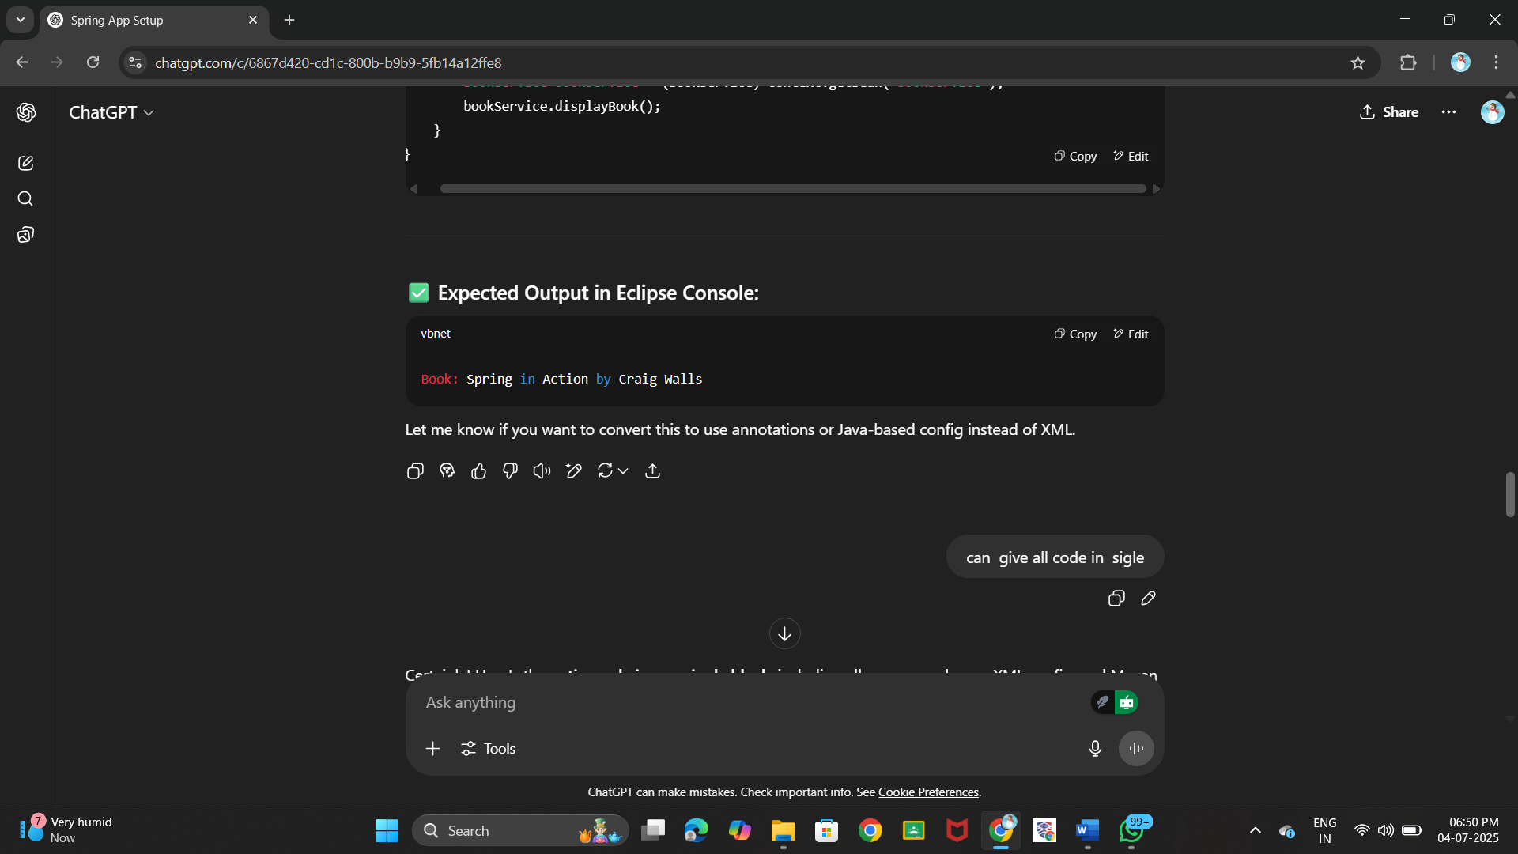

***Exercise 2: Implementing Dependency Injection***

***Scenario:***

***In the library management application, you need to manage the dependencies between the BookService and BookRepository classes using Spring's IoC and DI.***

***Steps:***

1. ***Modify the XML Configuration:***
   * ***Update applicationContext.xml to wire BookRepository into BookService.***
2. ***Update the BookService Class:***
   * ***Ensure that BookService class has a setter method for BookRepository.***
3. ***Test the Configuration:***
   * ***Run the LibraryManagementApplication main class to verify the dependency injection.***

**CODE:**

*pom.xml*

<project xmlns="http://maven.apache.org/POM/4.0.0"

xmlns:xsi="http://www.w3.org/2001/XMLSchema-instance"

xsi:schemaLocation="http://maven.apache.org/POM/4.0.0

http://maven.apache.org/xsd/maven-4.0.0.xsd">

<modelVersion>4.0.0</modelVersion>

<groupId>com.library</groupId>

<artifactId>LibraryManagement</artifactId>

<version>1.0-SNAPSHOT</version>

<dependencies>

<!-- Spring Core Dependency -->

<dependency>

<groupId>org.springframework</groupId>

<artifactId>spring-context</artifactId>

<version>5.3.31</version>

</dependency>

</dependencies>

</project>

*applicationContext.xml*

<?xml version="1.0" encoding="UTF-8"?>

<beans xmlns="http://www.springframework.org/schema/beans"

xmlns:xsi="http://www.w3.org/2001/XMLSchema-instance"

xsi:schemaLocation="http://www.springframework.org/schema/beans

http://www.springframework.org/schema/beans/spring-beans.xsd">

<!-- BookRepository Bean -->

<bean id="bookRepository" class="com.library.repository.BookRepository"/>

<!-- BookService Bean with Setter Injection -->

<bean id="bookService" class="com.library.service.BookService">

<property name="bookRepository" ref="bookRepository"/>

</bean>

</beans>

*BookRepository.java*

package com.library.repository;

public class BookRepository {

public String getBookDetails() {

return "Book: Spring in Action by Craig Walls";

}

}

*BookService.java*

package com.library.service;

import com.library.repository.BookRepository;

public class BookService {

private BookRepository bookRepository;

// Setter method for Dependency Injection

public void setBookRepository(BookRepository bookRepository) {

this.bookRepository = bookRepository;

}

public void displayBook() {

System.out.println(bookRepository.getBookDetails());

}

}

*LibraryManagementApplication.java*

package com.library;

import org.springframework.context.ApplicationContext;

import org.springframework.context.support.ClassPathXmlApplicationContext;

import com.library.service.BookService;

public class LibraryManagementApplication {

public static void main(String[] args) {

ApplicationContext context = new ClassPathXmlApplicationContext("applicationContext.xml");

BookService bookService = (BookService) context.getBean("bookService");

bookService.displayBook();

}

}

**OUTPUT :**

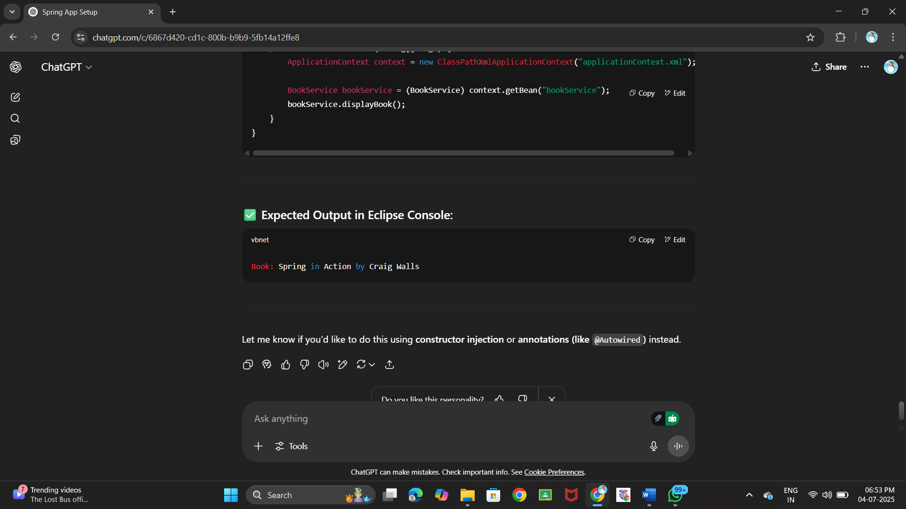

***Exercise 4: Creating and Configuring a Maven Project***

***Scenario:***

***You need to set up a new Maven project for the library management application and add Spring dependencies.***

***Steps:***

1. ***Create a New Maven Project:***
   * ***Create a new Maven project named LibraryManagement.***
2. ***Add Spring Dependencies in pom.xml:***
   * ***Include dependencies for Spring Context, Spring AOP, and Spring WebMVC.***
3. ***Configure Maven Plugins:***
   * ***Configure the Maven Compiler Plugin for Java version 1.8 in the pom.xml file.***

**CODE:**

*pom.xml*

<project xmlns="http://maven.apache.org/POM/4.0.0"

xmlns:xsi="http://www.w3.org/2001/XMLSchema-instance"

xsi:schemaLocation="http://maven.apache.org/POM/4.0.0

http://maven.apache.org/xsd/maven-4.0.0.xsd">

<modelVersion>4.0.0</modelVersion>

<groupId>com.library</groupId>

<artifactId>LibraryManagement</artifactId>

<version>1.0-SNAPSHOT</version>

<properties>

<maven.compiler.source>1.8</maven.compiler.source>

<maven.compiler.target>1.8</maven.compiler.target>

</properties>

<dependencies>

<!-- Spring Context -->

<dependency>

<groupId>org.springframework</groupId>

<artifactId>spring-context</artifactId>

<version>5.3.31</version>

</dependency>

<!-- Spring AOP -->

<dependency>

<groupId>org.springframework</groupId>

<artifactId>spring-aop</artifactId>

<version>5.3.31</version>

</dependency>

<!-- Spring Web MVC -->

<dependency>

<groupId>org.springframework</groupId>

<artifactId>spring-webmvc</artifactId>

<version>5.3.31</version>

</dependency>

<!-- Servlet API (required for Spring MVC only at compile time) -->

<dependency>

<groupId>javax.servlet</groupId>

<artifactId>javax.servlet-api</artifactId>

<version>4.0.1</version>

<scope>provided</scope>

</dependency>

</dependencies>

<build>

<plugins>

<!-- Compiler Plugin for Java 8 -->

<plugin>

<groupId>org.apache.maven.plugins</groupId>

<artifactId>maven-compiler-plugin</artifactId>

<version>3.8.1</version>

<configuration>

<source>1.8</source>

<target>1.8</target>

</configuration>

</plugin>

</plugins>

</build>

</project>

**OUTPUT:**

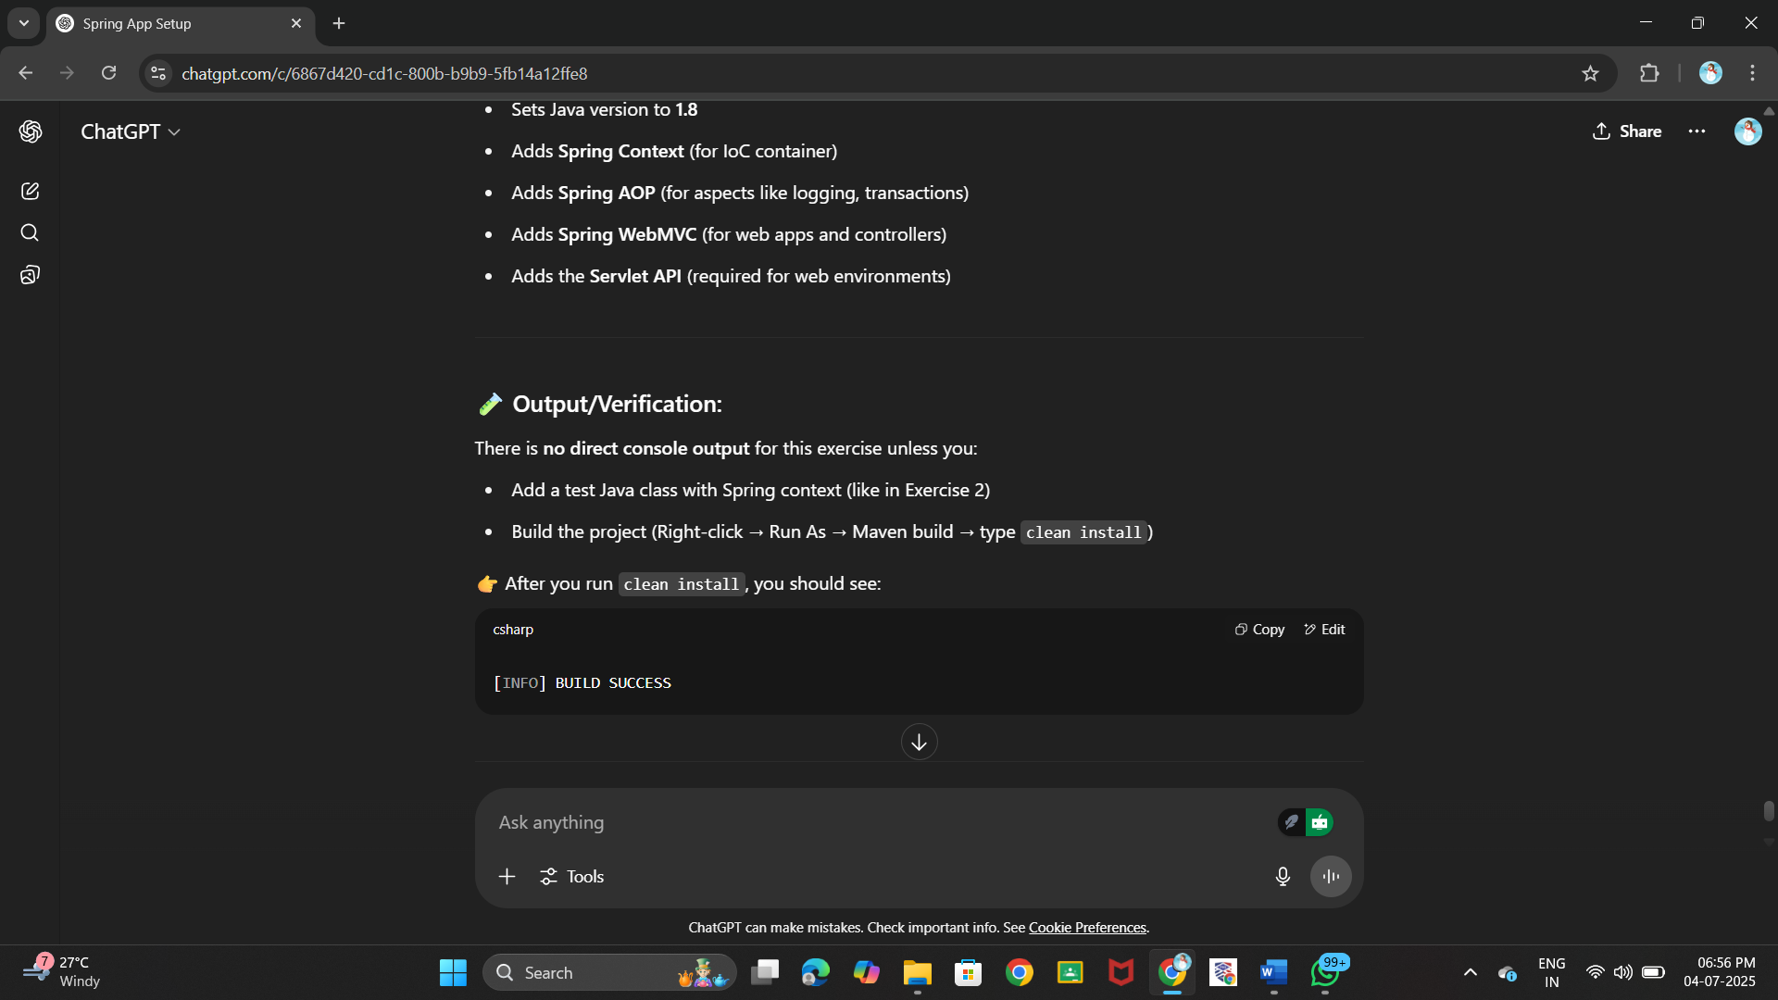

***Hands on 1***

***Spring Data JPA - Quick Example   
  
Software Pre-requisites***

* ***MySQL Server 8.0***
* ***MySQL Workbench 8***
* ***Eclipse IDE for Enterprise Java Developers 2019-03 R***
* ***Maven 3.6.2***

***Create a Eclipse Project using Spring Initializr***

* ***Go to***[***https://start.spring.io/***](https://start.spring.io/)
* ***Change Group as “com.cognizant”***
* ***Change Artifact Id as “orm-learn”***
* ***In Options > Description enter "Demo project for Spring Data JPA and Hibernate"***
* ***Click on menu and select "Spring Boot DevTools", "Spring Data JPA" and "MySQL Driver"***
* ***Click Generate and download the project as zip***
* ***Extract the zip in root folder to Eclipse Workspace***
* ***Import the project in Eclipse "File > Import > Maven > Existing Maven Projects > Click Browse and select extracted folder > Finish"***
* ***Create a new schema "ormlearn" in MySQL database. Execute the following commands to open MySQL client and create schema.***

***> mysql -u root -p***

***mysql> create schema ormlearn;***

* ***In orm-learn Eclipse project, open src/main/resources/application.properties and include the below database and log configuration.***

***# Spring Framework and application log***

***logging.level.org.springframework=info***

***logging.level.com.cognizant=debug***

***# Hibernate logs for displaying executed SQL, input and output***

***logging.level.org.hibernate.SQL=trace***

***logging.level.org.hibernate.type.descriptor.sql=trace***

***# Log pattern***

***logging.pattern.console=%d{dd-MM-yy} %d{HH:mm:ss.SSS} %-20.20thread %5p %-25.25logger{25} %25M %4L %m%n***

***# Database configuration***

***spring.datasource.driver-class-name=com.mysql.cj.jdbc.Driver***

***spring.datasource.url=jdbc:mysql://localhost:3306/ormlearn***

***spring.datasource.username=root***

***spring.datasource.password=root***

***# Hibernate configuration***

***spring.jpa.hibernate.ddl-auto=validate***

***spring.jpa.properties.hibernate.dialect=org.hibernate.dialect.MySQL5Dialect***

* ***Build the project using ‘mvn clean package -Dhttp.proxyHost=proxy.cognizant.com -Dhttp.proxyPort=6050 -Dhttps.proxyHost=proxy.cognizant.com -Dhttps.proxyPort=6050 -Dhttp.proxyUser=123456’ command in command line***
* ***Include logs for verifying if main() method is called.***

***import org.slf4j.Logger;***

***import org.slf4j.LoggerFactory;***

***private static final Logger LOGGER = LoggerFactory.getLogger(OrmLearnApplication.class);***

***public static void main(String[] args) {***

***SpringApplication.run(OrmLearnApplication.class, args);***

***LOGGER.info("Inside main");***

***}***

* ***Execute the OrmLearnApplication and check in log if main method is called.***

***SME to walk through the following aspects related to the project created:***

1. ***src/main/java - Folder with application code***
2. ***src/main/resources - Folder for application configuration***
3. ***src/test/java - Folder with code for testing the application***
4. ***OrmLearnApplication.java - Walkthrough the main() method.***
5. ***Purpose of @SpringBootApplication annotation***
6. ***pom.xml***
   1. ***Walkthrough all the configuration defined in XML file***
   2. ***Open 'Dependency Hierarchy' and show the dependency tree.***

***Country table creation***

* ***Create a new table country with columns for code and name. For sample, let us insert one country with values 'IN' and 'India' in this table.***

***create table country(co_code varchar(2) primary key, co_name varchar(50));***

* ***Insert couple of records into the table***

***insert into country values ('IN', 'India');***

***insert into country values ('US', 'United States of America');***

***Persistence Class - com.cognizant.orm-learn.model.Country***

* ***Open Eclipse with orm-learn project***
* ***Create new package com.cognizant.orm-learn.model***
* ***Create Country.java, then generate getters, setters and toString() methods.***
* ***Include @Entity and @Table at class level***
* ***Include @Column annotations in each getter method specifying the column name.***

***import javax.persistence.Column;***

***import javax.persistence.Entity;***

***import javax.persistence.Id;***

***import javax.persistence.Table;***

***@Entity***

***@Table(name="country")***

***public class Country {***

***@Id***

***@Column(name="code")***

***private String code;***

***@Column(name="name")***

***private String name;***

***// getters and setters***

***// toString()***

***}***

***Notes:***

* ***@Entity is an indicator to Spring Data JPA that it is an entity class for the application***
* ***@Table helps in defining the mapping database table***
* ***@Id helps is defining the primary key***
* ***@Column helps in defining the mapping table column***

***Repository Class - com.cognizant.orm-learn.CountryRepository***

* ***Create new package com.cognizant.orm-learn.repository***
* ***Create new interface named CountryRepository that extends JpaRepository<Country, String>***
* ***Define @Repository annotation at class level***

***import org.springframework.data.jpa.repository.JpaRepository;***

***import org.springframework.stereotype.Repository;***

***import com.cognizant.ormlearn.model.Country;***

***@Repository***

***public interface CountryRepository extends JpaRepository<Country, String> {***

***}***

***Service Class - com.cognizant.orm-learn.service.CountryService***

* ***Create new package com.cognizant.orm-learn.service***
* ***Create new class CountryService***
* ***Include @Service annotation at class level***
* ***Autowire CountryRepository in CountryService***
* ***Include new method getAllCountries() method that returns a list of countries.***
* ***Include @Transactional annotation for this method***
* ***In getAllCountries() method invoke countryRepository.findAll() method and return the result***

***Testing in OrmLearnApplication.java***

* ***Include a static reference to CountryService in OrmLearnApplication class***

***private static CountryService countryService;***

* ***Define a test method to get all countries from service.***

***private static void testGetAllCountries() {***

***LOGGER.info("Start");***

***List<Country> countries = countryService.getAllCountries();***

***LOGGER.debug("countries={}", countries);***

***LOGGER.info("End");***

***}***

* ***Modify SpringApplication.run() invocation to set the application context and the CountryService reference from the application context.***

***ApplicationContext context = SpringApplication.run(OrmLearnApplication.class, args);***

***countryService = context.getBean(CountryService.class);***

***testGetAllCountries();***

* ***Execute main method to check if data from ormlearn database is retrieved.***

**CODE:**

***Country.java***

package com.cognizant.ormlearn.model;

import javax.persistence.*;

@Entity

@Table(name = "country")

public class Country {

@Id

@Column(name = "co_code")

private String code;

@Column(name = "co_name")

private String name;

public String getCode() { return code; }

public void setCode(String code) { this.code = code; }

public String getName() { return name; }

public void setName(String name) { this.name = name; }

@Override

public String toString() {

return "Country [code=" + code + ", name=" + name + "]";

}

}

***CountryRepository.java***

package com.cognizant.ormlearn.repository;

import org.springframework.data.jpa.repository.JpaRepository;

import org.springframework.stereotype.Repository;

import com.cognizant.ormlearn.model.Country;

@Repository

public interface CountryRepository extends JpaRepository<Country, String> {}

***CountryService.java***

package com.cognizant.ormlearn.service;

import java.util.List;

import javax.transaction.Transactional;

import org.springframework.beans.factory.annotation.Autowired;

import org.springframework.stereotype.Service;

import com.cognizant.ormlearn.model.Country;

import com.cognizant.ormlearn.repository.CountryRepository;

@Service

public class CountryService {

@Autowired

private CountryRepository countryRepository;

@Transactional

public List<Country> getAllCountries() {

return countryRepository.findAll();

}

}

***OrmLearnApplication.java***

package com.cognizant.ormlearn;

import java.util.List;

import com.cognizant.ormlearn.model.Country;

import com.cognizant.ormlearn.service.CountryService;

import org.slf4j.Logger;

import org.slf4j.LoggerFactory;

import org.springframework.boot.SpringApplication;

import org.springframework.boot.autoconfigure.SpringBootApplication;

import org.springframework.context.ApplicationContext;

@SpringBootApplication

public class OrmLearnApplication {

private static final Logger LOGGER = LoggerFactory.getLogger(OrmLearnApplication.class);

private static CountryService countryService;

public static void main(String[] args) {

ApplicationContext context = SpringApplication.run(OrmLearnApplication.class, args);

LOGGER.info("Inside main");

countryService = context.getBean(CountryService.class);

testGetAllCountries();

}

private static void testGetAllCountries() {

LOGGER.info("Start");

List<Country> countries = countryService.getAllCountries();

LOGGER.debug("countries={}", countries);

LOGGER.info("End");

}

}

**OUTPUT:**

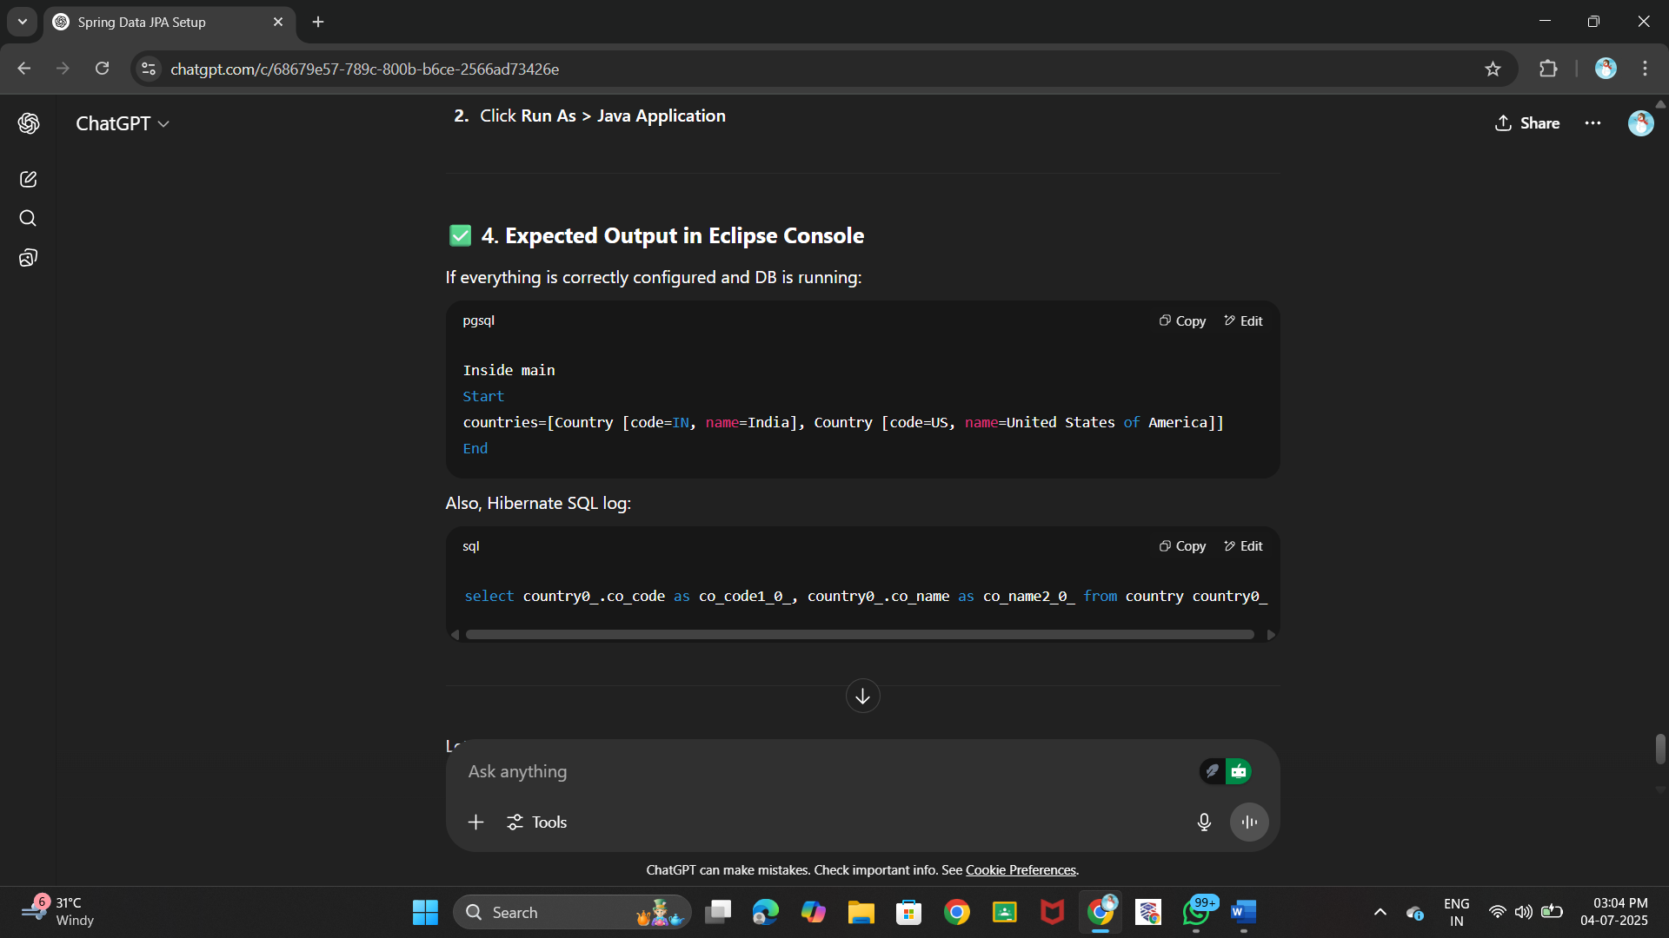



***Hands on 4***

***Difference between JPA, Hibernate and Spring Data JPA   
  
Java Persistence API (JPA)***

* ***JSR 338 Specification for persisting, reading and managing data from Java objects***
* ***Does not contain concrete implementation of the specification***
* ***Hibernate is one of the implementation of JPA***

***Hibernate***

* ***ORM Tool that implements JPA***

***Spring Data JPA***

* ***Does not have JPA implementation, but reduces boiler plate code***
* ***This is another level of abstraction over JPA implementation provider like Hibernate***
* ***Manages transactions***

***Refer code snippets below on how the code compares between Hibernate and Spring Data JPA  
Hibernate***

***/* Method to CREATE an employee in the database */***

***public Integer addEmployee(Employee employee){***

***Session session = factory.openSession();***

***Transaction tx = null;***

***Integer employeeID = null;***

***try {***

***tx = session.beginTransaction();***

***employeeID = (Integer) session.save(employee);***

***tx.commit();***

***} catch (HibernateException e) {***

***if (tx != null) tx.rollback();***

***e.printStackTrace();***

***} finally {***

***session.close();***

***}***

***return employeeID;***

***}***

***Spring Data JPA  
EmployeeRespository.java***

***public interface EmployeeRepository extends JpaRepository<Employee, Integer> {***

***}***

***EmployeeService.java***

***@Autowire***

***private EmployeeRepository employeeRepository;***

***@Transactional***

***public void addEmployee(Employee employee) {***

***employeeRepository.save(employee);***

***}***

**​​​​​​​ CODE:**

***Employee.java***

package com.example.springdemo.model;

import javax.persistence.*;

@Entity

@Table(name = "employee")

public class Employee {

@Id

private int id;

private String name;

private double salary;

public int getId() { return id; }

public void setId(int id) { this.id = id; }

public String getName() { return name; }

public void setName(String name) { this.name = name; }

public double getSalary() { return salary; }

public void setSalary(double salary) { this.salary = salary; }

@Override

public String toString() {

return "Employee [id=" + id + ", name=" + name + ", salary=" + salary + "]";

}

}

***EmployeeRepository.java***

package com.example.springdemo.repository;

import org.springframework.data.jpa.repository.JpaRepository;

import com.example.springdemo.model.Employee;

public interface EmployeeRepository extends JpaRepository<Employee, Integer> {}

***EmployeeService.java***

package com.example.springdemo.service;

import java.util.List;

import org.springframework.beans.factory.annotation.Autowired;

import org.springframework.stereotype.Service;

import com.example.springdemo.model.Employee;

import com.example.springdemo.repository.EmployeeRepository;

@Service

public class EmployeeService {

@Autowired

private EmployeeRepository employeeRepository;

public void addEmployee(Employee employee) {

employeeRepository.save(employee);

}

public List<Employee> getAllEmployees() {

return employeeRepository.findAll();

}

}

***SpringdemoApplication.java***

package com.example.springdemo;

import java.util.List;

import com.example.springdemo.model.Employee;

import com.example.springdemo.service.EmployeeService;

import org.springframework.beans.factory.annotation.Autowired;

import org.springframework.boot.SpringApplication;

import org.springframework.boot.autoconfigure.SpringBootApplication;

import org.springframework.context.ApplicationContext;

@SpringBootApplication

public class SpringdemoApplication {

private static EmployeeService employeeService;

public static void main(String[] args) {

ApplicationContext context = SpringApplication.run(SpringdemoApplication.class, args);

employeeService = context.getBean(EmployeeService.class);

Employee e = new Employee();

e.setId(3);

e.setName("Anjali");

e.setSalary(70000);

employeeService.addEmployee(e);

List<Employee> all = employeeService.getAllEmployees();

all.forEach(System.out::println);

}

}

**OUTPUT :**

